**LAYOUT MANAGER**

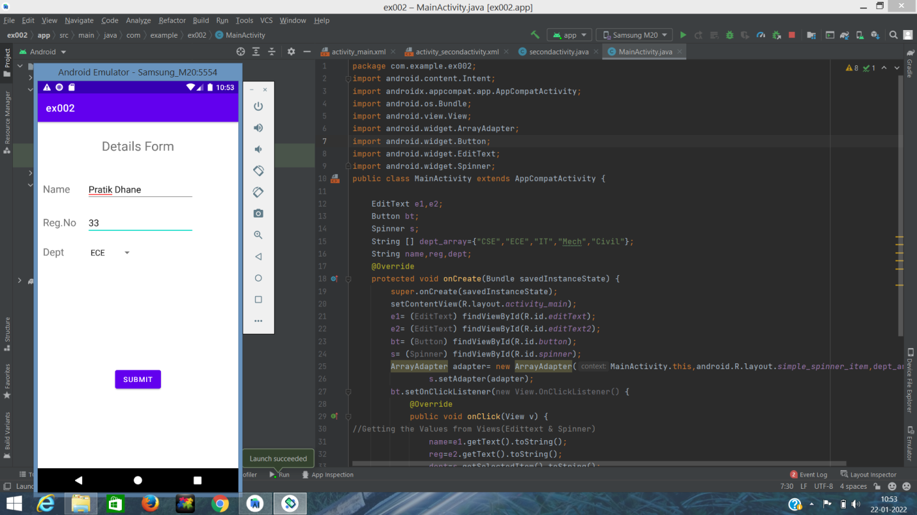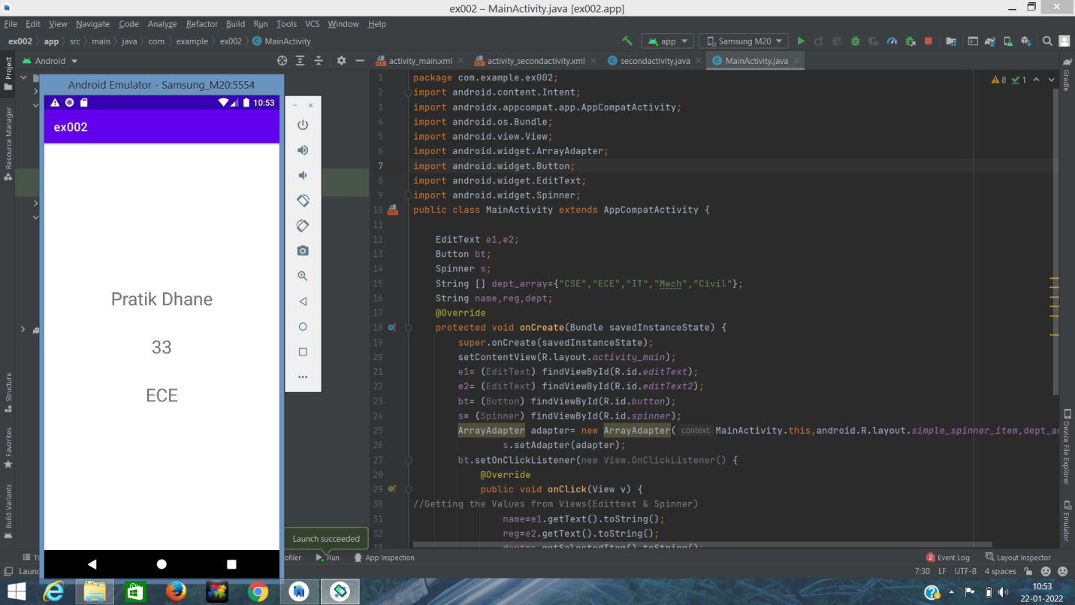

**CODE IN ACTIVITY MAIN.JAVA:-**

package com.example.ex002;  
import android.content.Intent;  
import androidx.appcompat.app.AppCompatActivity;  
import android.os.Bundle;  
import android.view.View;  
import android.widget.ArrayAdapter;  
import android.widget.Button;  
import android.widget.EditText;  
import android.widget.Spinner;  
public class MainActivity extends AppCompatActivity {  
  
 EditText e1,e2;  
 Button bt;  
 Spinner s;  
 String [] dept_array={"CSE","ECE","IT","Mech","Civil"};  
 String name,reg,dept;  
 @Override  
 protected void onCreate(Bundle savedInstanceState) {  
 super.onCreate(savedInstanceState);  
 setContentView(R.layout.*activity_main*);  
 e1= (EditText) findViewById(R.id.*editText*);  
 e2= (EditText) findViewById(R.id.*editText2*);  
 bt= (Button) findViewById(R.id.*button*);  
 s= (Spinner) findViewById(R.id.*spinner*);  
 ArrayAdapter adapter= new ArrayAdapter(MainActivity.this,android.R.layout.*simple_spinner_item*,dept_array);  
 s.setAdapter(adapter);  
 bt.setOnClickListener(new View.OnClickListener() {  
 @Override  
 public void onClick(View v) {  
//Getting the Values from Views(Edittext & Spinner)  
 name=e1.getText().toString();  
 reg=e2.getText().toString();  
 dept=s.getSelectedItem().toString();  
 Intent i = new Intent(MainActivity.this,secondactivity.class);  
 i.putExtra("name_key", name);  
 i.putExtra("reg_key",reg);  
 i.putExtra("dept_key", dept);  
 startActivity(i);  
 }  
 });  
 }  
}

**CODE IN XML:-**

<?xml version="1.0" encoding="utf-8"?>  
<RelativeLayout xmlns:android="http://schemas.android.com/apk/res/android"  
 xmlns:tools="http://schemas.android.com/tools"  
 android:layout_width="match_parent"  
 android:layout_height="match_parent"  
 tools:context=".MainActivity">  
 <LinearLayout  
 android:layout_width="match_parent"  
 android:layout_height="100dp">  
 <TextView  
 android:id="@+id/textView"  
 android:layout_width="match_parent"  
 android:layout_height="wrap_content"  
 android:layout_margin="30dp"  
 android:text="Details Form"  
 android:textSize="25sp"  
 android:gravity="center"/>  
 </LinearLayout>  
 <GridLayout  
 android:id="@+id/gridLayout"  
 android:layout_width="match_parent"  
 android:layout_height="match_parent"  
 android:layout_marginTop="100dp"  
 android:layout_marginBottom="200dp"  
 android:columnCount="2"  
 android:rowCount="3">  
 <TextView  
 android:id="@+id/textView1"  
 android:layout_width="wrap_content"  
 android:layout_height="wrap_content"  
 android:layout_margin="10dp"  
 android:layout_row="0"  
 android:layout_column="0"  
 android:text="Name"  
 android:textSize="20sp"  
 android:gravity="center"/>  
 <EditText  
 android:id="@+id/editText"  
 android:layout_width="wrap_content"  
 android:layout_height="wrap_content"  
 android:layout_margin="10dp"  
 android:layout_row="0"  
 android:layout_column="1"  
 android:ems="10"/>  
 <TextView  
 android:id="@+id/textView2"  
 android:layout_width="wrap_content"  
 android:layout_height="wrap_content"  
 android:layout_margin="10dp"  
 android:layout_row="1"  
 android:layout_column="0"  
 android:text="Reg.No"  
 android:textSize="20sp"  
 android:gravity="center"/>  
 <EditText  
 android:id="@+id/editText2"  
 android:layout_width="wrap_content"  
 android:layout_height="wrap_content"  
 android:layout_margin="10dp"  
 android:layout_row="1"  
 android:layout_column="1"  
 android:inputType="number"  
 android:ems="10"/>  
 <TextView  
 android:id="@+id/textView3"  
 android:layout_width="wrap_content"  
 android:layout_height="wrap_content"  
 android:layout_margin="10dp"  
 android:layout_row="2"  
 android:layout_column="0"  
 android:text="Dept"  
 android:textSize="20sp"  
 android:gravity="center"/>  
 <Spinner  
 android:id="@+id/spinner"  
 android:layout_width="wrap_content"  
 android:layout_height="wrap_content"  
 android:layout_margin="10dp"  
 android:layout_row="2"  
 android:layout_column="1"  
 android:spinnerMode="dropdown"/>  
 </GridLayout>  
 <Button  
 android:id="@+id/button"  
 android:layout_width="wrap_content"  
 android:layout_height="wrap_content"  
 android:layout_alignParentBottom="true"  
 android:layout_centerInParent="true"  
 android:layout_marginBottom="150dp"  
 android:text="Submit"/>  
</RelativeLayout>

**CODE IN SECONDACTIVITY.JAVA:-**

package com.example.ex002;  
import androidx.appcompat.app.AppCompatActivity;  
import android.content.Intent;  
import android.os.Bundle;  
import android.widget.TextView;  
public class secondactivity extends AppCompatActivity { TextView t1,t2,t3;  
 String name,reg,dept;  
 @Override  
 protected void onCreate(Bundle savedInstanceState) { super.onCreate(savedInstanceState); setContentView(R.layout.activity_secondactivity);  
 t1= (TextView)findViewById(R.id.textView1);  
 t2= (TextView)findViewById(R.id.textView2);  
 t3= (TextView)findViewById(R.id.textView3);  
 Intent i = getIntent();  
 name=i.getStringExtra("name_key");  
 reg=i.getStringExtra("reg_key");  
 dept=i.getStringExtra("dept_key");  
//Setting the Values to Intent  
 t1.setText(name);  
 t2.setText(reg);  
 t3.setText(dept);  
 }  
}

**CODE IN SECONDACTIVITY.XML:-**

<?xml version="1.0" encoding="utf-8"?>  
<LinearLayout xmlns:android="http://schemas.android.com/apk/res/android"  
 xmlns:tools="http://schemas.android.com/tools"  
 android:layout_width="match_parent"  
 android:layout_height="match_parent"  
 tools:context="com.example.ex002.secondactivity"  
 android:orientation="vertical"  
 android:gravity="center">  
 <TextView  
 android:id="@+id/textView1"  
 android:layout_width="wrap_content"  
 android:layout_height="wrap_content"  
 android:layout_margin="20dp"  
 android:text="New Text"  
 android:textSize="30sp"/>  
 <TextView  
 android:id="@+id/textView2"  
 android:layout_width="wrap_content"  
 android:layout_height="wrap_content"  
 android:layout_margin="20dp"  
 android:text="New Text"  
 android:textSize="30sp"/>  
 <TextView  
 android:id="@+id/textView3"  
 android:layout_width="wrap_content"  
 android:layout_height="wrap_content"  
 android:layout_margin="20dp"  
  
 android:text="New Text"  
 android:textSize="30sp"/>  
</LinearLayout>